How to clone the wireless router WIFI
Product line: Powerline Model number:PA6

With WiFi clone function, the extender can copy the WiFi name and password of your existing
wireless router (with WPS enabled), giving you a seamless roaming wireless networking
experience.

Steps are as follow：
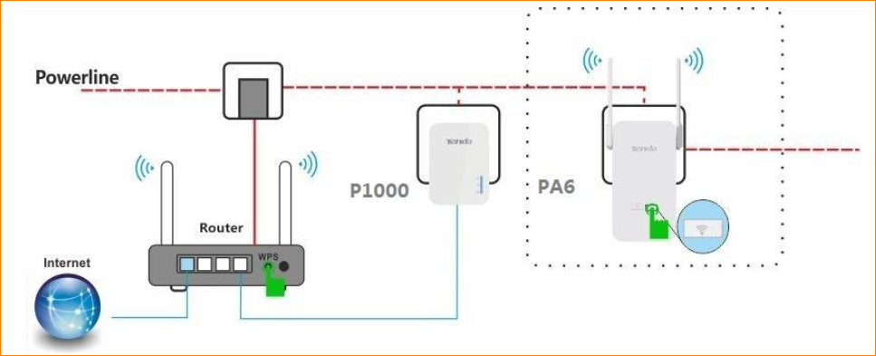
1. Plug the extender (PA6) next to the wireless router (with WPS enabled).
2. Press the WPS button on the wireless router.
3. Then press the WiFi button on the extender (PA6) and then release it. The WiFi LED will blink quickly for a few seconds.
4. After successful cloning, relocate the extender (PA6) to your chosen position

